**CS359 - Computer Network Lab**

**Lab 1b**

Tarusi Mittal 1901CS65

**Architecture:**

This class tells us about the various events that take place in our process:

EVENT0 = generation of packet

EVENT1 = reaching Queue time

EVENT2 = leaving queue time

EVENT3 = reaching sink time

**EVENTS CLASS**

1. eid: it the stage ID where our packet is currently at
2. pid: It the packet id of our packet
3. currentTime: This time is the time when our packet has reached the stage with that eid

**SOURCE INFO CLASS**

1. genRate: It is the rate of generation of the packets by the source
2. sourceID: It is the unique source Id given to every source
3. bandSoSwi: It is the bandwidth speed between the Source and The Switch

This class contains the information about the sources i.e. We are creating the sources by this class

This class contains the information about the packets whoch are created by sources and and going to the sink

i.e it creates the packets

**PACKET INFO CLASS**

1. packetId: It is the unique Id of every packet
2. queueIn: The time the packet gets inside the queue
3. queueOut: The time the packet gets out of the queue
4. sourceID: The source Id of the source from where the packet was generated
5. generationTime: The time the packet was generated

This class handles what is going inside the switch like the queue generation and the rate at which the packets are transferred to the sink

**SWITCH INFO CLASS**

1. bandSwSin: The bandwidth between the Switch and the Sink
2. qSize: The size of the queue present in the Switch

**EXPLANATION:**

When we start our program the user is given the option either to use the default values for the variables such as simulation tine, no of sources, bandwidth etc. or the user can input the values. Once this decision is made our actual process starts.

**Event 0:** Now our event 0 start where our packet generation takes place from the sources through the packetInfo class. All the packets that are generated are sorted into the priority queue with event id 0 according to the time that they are generated. From here to keep our process running we take one element out of our queue (with the most priority i.e., which was generated the earliest) and keep updating their event in the queue itself. Simultaneously after every 1/generationRate time later a new packet is generated from the source.

**Event 0 -> Event 1 -> Event 2:** From here our packet enters the sink and simultaneously the event id is now changed to 1.

Now after this we have two conditions in our question:

1. When our Queue size is infinite: In this case the packets simply go from event 1 to the event 2 without experiencing any drop in their number. In this case we are simply changing the bandwidth to see the relation between our average delay and the utilization factor.

2. When our Queue size is finite: In this case, the packets can have the tendency to drop which will depend upon our transmission speed from switch to sink since we are keeping all the other factors constant. In this case we will calculate the no of packets dropped and the no of packets that actually were arriving. These calculations will take place in out Event 2 in the Switch

**Event 2 -> Event 3:** In this all our packets simply leaves from the switch and goes inside our sink. Here we count the total no of packets reaching the sink as it was required to calculate avg delay in our part 1.

Basically I the whole process for Part 1 we are varying the bandwidth to see the relation between our utilization factor and the avg delay and in the second part we are changing our transmission speed to see the relation between Packet drop rate and the utilization factor

If λ denotes the arrival rate of the packets in the queue and µ is the system transmission capacity, then the utilization factor U of the queue is given as U = $\frac{λ}{µ}$.

**1. The average delay of the sources with respect to the utilization factor**

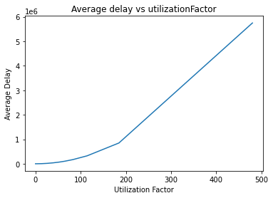

In this part we are keeping our queue size infinite and we are varying the bandwidth speed from of our source to sink. We can see that while the utilization factor is increasing the average delay also increases because we know that utilisation factor will increase if we decrease the band width which surely should increase the avg delay.

The code implementation and output for this part can be seen at:

<https://colab.research.google.com/drive/1ESAMJrPmOGxAyC1XXsBEq4433_E8N7WA?usp=sharing>

**2. if the queue size is fixed then the packet loss rate at the switch with respect to the utilization factor**

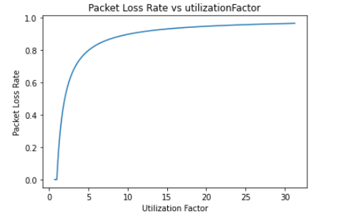

From the graph we can see

1. Below a certain utilization factor value the packet loss rate is always zero

2. Now we have limited our queue size and our arrival of packet is also constant. As we know the utilization factor depends of arrival rate packet length and transmission speed. Since all the other factors are constant. And the relation of U with transmission speed is inversely proportional. As the transmission speed with decrease the utilisation factor will increase. Also we know if the transmission speed will increase the queue will be emptied factor and the packet loss rate will be less. There fore as utilization factor decreases the packet loss rate also decreases.

The Code Implementation and output can be seen at:

<https://colab.research.google.com/drive/1ArlnEpfzayD6BWEa2b5eFrxtPCCxAcN1?usp=sharing>